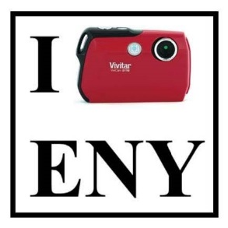

You have been selected to participate in a special Good Shepherd Services program project called “THIS IS MY COMMUNITY”. Good Shepherd Services recieved a small grant to fund this project so that we can get to know you, your life, and your neighborhood better. This evening, you will be given a camera so that you can tell us the story of life in your neighborhood through photos. Think of it like an Instagram account for East New York.

Your task: in the next 6 days, take up to 10 photos that capture what your neighborhood is to you. Here are some ideas to get you started.
- These are places where I feel like I belong.
- This is my community at its best.
- This is something that I would like to change.

BRAINSTORM

What are some places, people, objects, or events that you want to take pictures of?

These are places where I feel like I belong.

This is my community at its best.

This is something that I would like to change.

USING YOUR CAMERA

Shutter Button (for taking a picture)
Power Button

Zoom Buttons (for bringing the object closer or farther away)

Multi-Step Quick Guide

To review your photos:
- Press the “Mode” button twice
- Scroll left and right using the scroll buttons
- To begin taking pictures again, press the “Mode” button

To delete a photo:
- Put your camera in review mode (see instructions above)
- Scroll until you have found the photo you would like to delete
- Press the “Set” button
- Using the up and down scroll buttons, highlight either “Delete this Photo” or “Delete All Images”
- Press the “Set” button to delete
Scroll Right & Delete (when reviewing photos, press this button to scroll / To see the last photo you took, press this button)
Scroll Down (move the cursor down by pressing this button.)
Set Button (When reviewing photos, press this button to delete)
Scroll Left
(When reviewing photos, press this button to scroll)

Scroll Up & Flash (move the cursor up by pressing this button. Press once to turn on the flash. When flash is on, press three times to turn the flash off.)
Mode Button (press once for video mode, press twice to review your photos)

PHOTOGRAPHY (& Life) TIPS FROM A PROFESSIONAL PHOTOGRAPHER

- Zoom in on the subject (Pay attention to what’s in front of you).
- The “Rule of Halves” (Rules are good, most of the time).
- Speak up (Closed mouths don’t get fed).
- If you are photographing a person, encourage him or her to “Be Yourself” (…be yourself!).
- Find a unique perspective. (When faced with a challenge, think outside the box).

NEXT STEPS

- Go have fun! Be creative! Express yourself!

- Choose the top 10 photos that represent your community and delete the rest.

- Return your camera with 10 photos only to your program’s point person on Wednesday, October 26th between 9am and 5pm.

- Join us to talk about your shots on Friday, November 4th from 4:30-6:30pm. At the meeting, you’ll get printed copies of your photos, your gift card, and other exciting things!

